Implementing R Hypothesis Testing in RGui

Glenn Sobbing

MIS500 – Foundations of Data Analytics

Colorado State University – Global Campus

Dr. Dwight Davis

9/8/2019

Implementing R Hypothesis Testing in RGui

The goal of this assignment was to get the provided code to run within the default R IDE. Please find screenshots below that contain my output, from the R IDE. Note that the failure to download dplyr is just because I have previously used it before.

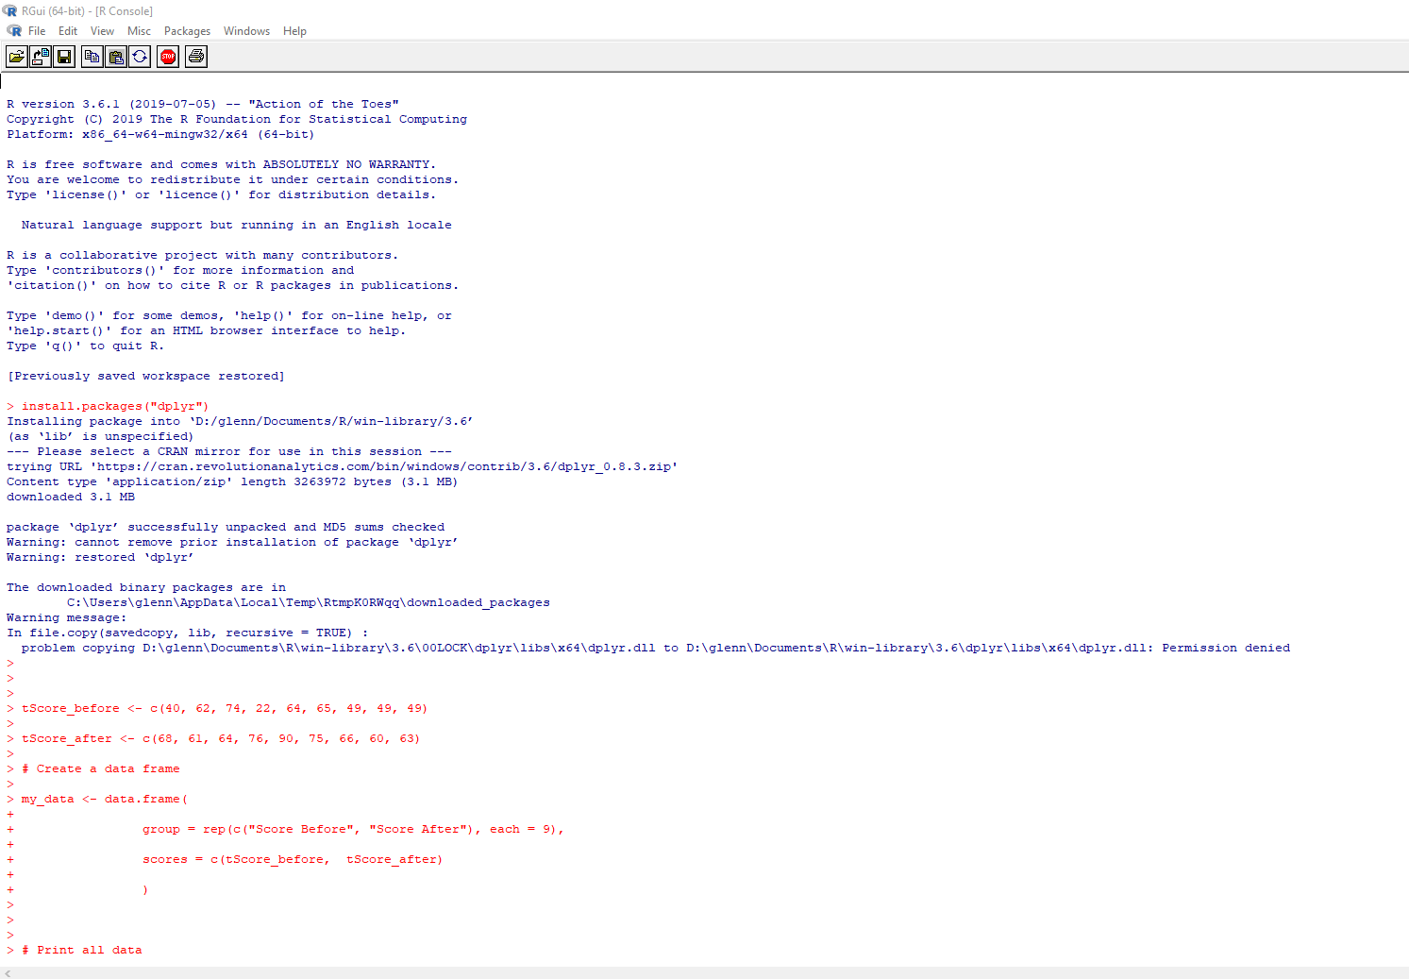

*Figure 1.* Attempting to download dplyr, proof of RGui use, R Version information

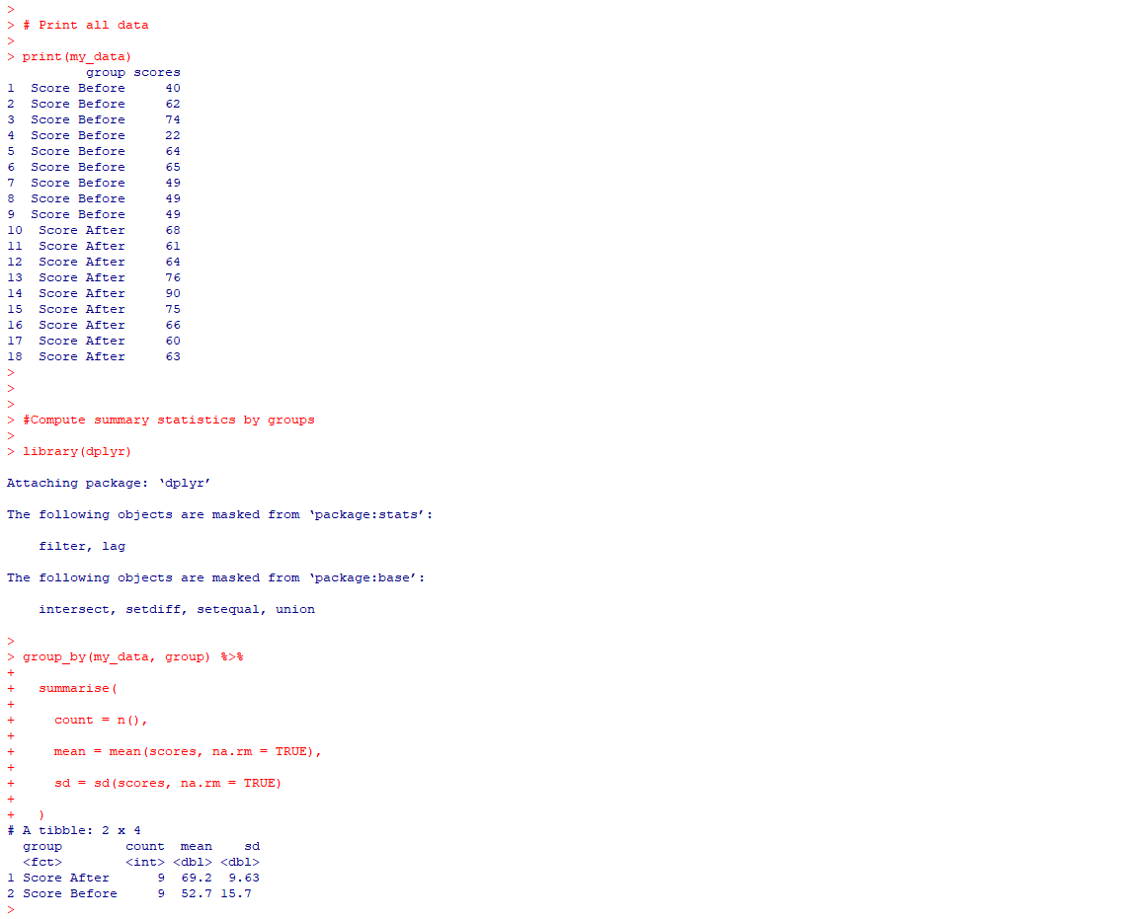

*Figure 2:* Printing of data, calling dplyr, group_by statement that accepts multiple inputs, printing summary statistics.

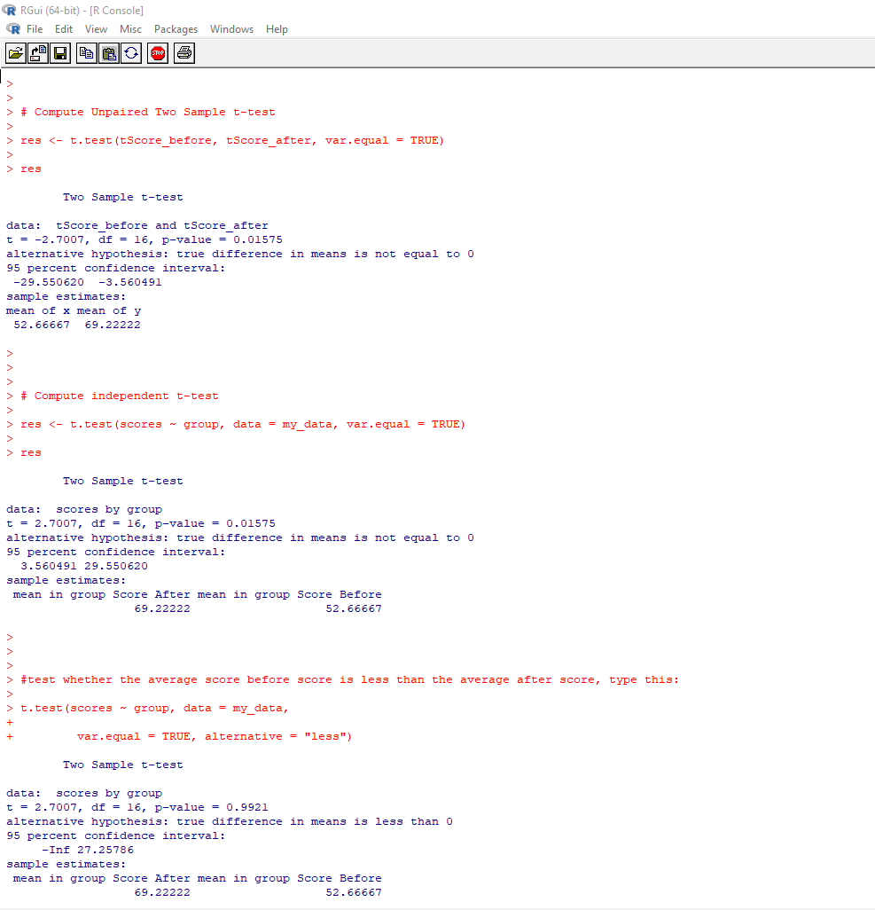

*Figure 3:* An unpaired two sample t-test, an independent t-test, and a test of which average mean is smaller.

Thank you for your time.